CHAPTER 9: Sedimentary, igneous and metamorphic rocks
Worksheet 9.1

Identifying and classifying minerals
Student: Class:

Identifying minerals  1. Two common rocks are composed of the minerals shown in the images at right. Limestone contains calcite, and sandstone contains quartz. | 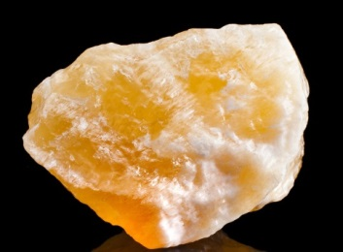 | 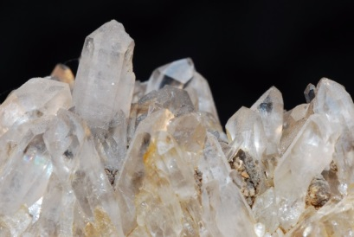
Calcite |  | Quartz

The following table provides information about the properties of these minerals.
Mineral | Colour | Streak (colour of powdered mineral) | Hardness | Lustre
Calcite | Colourless, white | White | 3 | Dull to vitreous
Quartz | Colourless, purple, red, yellow | White | 7 | Vitreous
(a) Explain how calcite crystals can be distinguished from quartz crystals.

(b) Pure quartz crystals are colourless. Explain the large variation in colour indicated in the table.

Creating a classification key
2. Use the following table to create a written classification key for these minerals.
Mineral | Colour | Streak | Hardness | Lustre
Chalcopyrite | Yellow | Green, black | 3.5–4 | Metallic
Chlorite | Grey | White, green | 2.2–5 | Pearly
Galena | Grey | Grey | 2.5 | Metallic
Haematite | Grey | Red, brown | 5–6 | Metallic
Magnetite | Black | Black | 5.5–6.5 | Metallic
Pyrite | Yellow | Green | 6–6.5 | Metallic
Key:
1A.
1B.
Calcite photo: madllen / 123RF.com
Quartz photo: thomaseder / 123RF.com

